Project: Woodson Park Academy & YMCA-ELC
Week Ending: August 16th, 2019

THIS WEEK:
- Storm Structures delivered
- Demo continued
- Hauled off mulch
- CDCC staked out for 6 additional bores

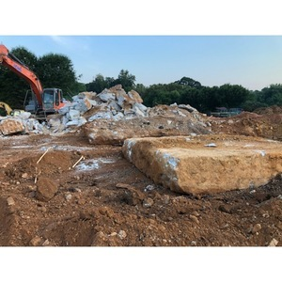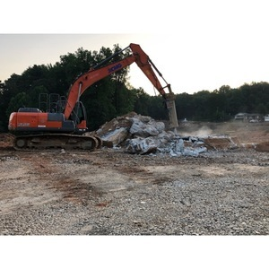
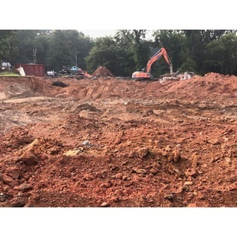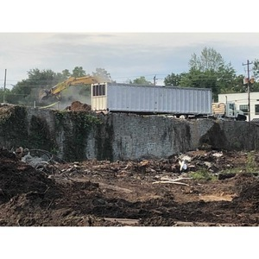

NEXT WEEK – August 19 thru August 23:
- Continue with building pad
- Haul off of concrete debris
- Trash clean up

PAYMENT STATUS:
- Gmp#1 $3,703,488.00
  - Paid to date amount $0.00
- GMP#2 $28,686,295.00
  - Paid to date amount $0.00

SCHEDULED DATE OF SUBSTANTIAL COMPLETION
- WPA – September 18, 2020
- YMCA-ELC - September 16, 2020

PREPARED BY:
- Matt Dauber, Carroll Daniel Construction Co.

